# Every Kid Can Learn to Read

Introductory video

Often, schools settle for kids who can’t read, because people just accept that many kids never will.

But sub-literate kids are not an inescapable fact of nature.

Script

“West Dunbartonshire” sounds like a place in T*he Hobbit* movies.

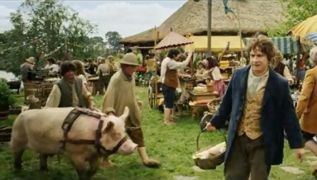

It’s actually a very real town in Scotland.

[Zoom in on globe]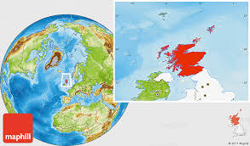

And it’s where 60,000 kids were given the kind of reading support all kids should get.

[.]

In most cities, it’s just taken for granted that many kids will *not* learn to read. Black kids. Brown kids. Poor kids. Dyslexic kids.

Even the most optimistic experts regularly say that 3-5% of kids can’t learn to read well.

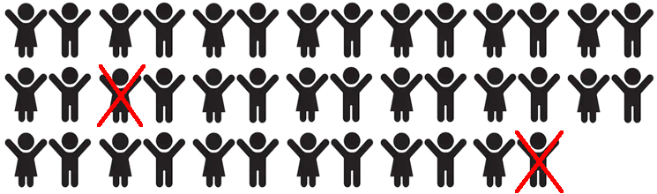

In West Dunbartonshire, they refused to accept this. They asked what would happen if every kid were given everything they needed to learn to read.

Sure enough, 59,994 out of 60,000 kids learned to read. Only .01%—one one hundredth of one percent didn’t.



That’s a big difference.

To be sure, this is a unique study. It’s not been verified elsewhere.

But we do know this: Science tells us far more kids can learn to read, and read better.

In this section, you’ll learn from some teens who did not get the basics they needed, and who are just discovering in high school exactly what they were never given.

And you’ll learn some of the science that explains why all readers need to know these basics.

Teen Literacy team

High School Remixed

Icon made by Freepik from www.flaticon.com"